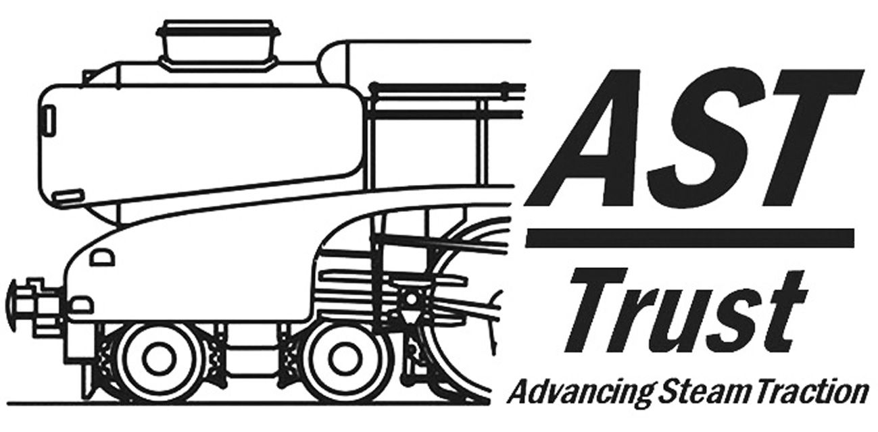
Membership Application Form

Name __________________________
Address ______________________________________
Phone Number ______________ Email address __________________
Note: Applicants will normally be granted Associate Membership for which voting rights are excluded. Full membership (with voting rights) is available by invitation to Associate Members who are involved in the group’s activities. Membership fees are currently set at £12.50 per annum for associate membership and £25.00 per annum for full membership. [Students should apply using the Student Membership form.] The membership year runs from 1 Jan to 31 Dec; a 50% fee discount is offered to new members joining on or after 1 July.
Payment may be made via PayPal to info@advanced-steam.org, or by direct bank transfer (see below), or by cheque, postal order, banker's draft, or PayPal. If paying by cheque, postal order or banker's draft, please make payment to: "Advanced Steam Traction Trust" and post with this form to the Membership Secretary:
Chris Newman, Flat 4, 2 Kimmerghame View, Edinburgh EH4 2GP
If you would like to make an additional one-off or annual donation to Advanced Steam Traction Trust, please complete one or both of the options below:
Membership Fee £ ____________
Voluntary donation £ ____________
Total amount paid: £ ____________ Payment method: Cheque / Bank Transfer / PayPal
You will be asked to confirm your agreement to abide by the Rules and Constitution of the Advanced Steam Traction Trust which will be forwarded to you on acceptance of your application.

Note: Your name and contact details will be held on computer for accounting & mailing purposes only & will not be passed to any third party.

MEMBERSHIP FEE PAYMENT OPTIONS
Membership fees may be paid by cheque, bank transfer or via PayPal (through the “How to Join” page of ASTT’s website), however members are requested to set up a standing order with their bank for annual fees to be paid automatically on 1st Jan each year.
Payments by bank transfer and by standing order should be made to:
HSBC Letchworth; Sort Code: 40-28-14; Account No: 41760947; IBAN: GB69MIDL40281441760947
Account Name: Advanced Steam Traction Trust. Please include your name in the “Reference” section.
Cheque payment should be made out to Advanced Steam Traction Trust and posted to
The Membership Secretary, ASTT, Flat 4, 2 Kimmerghame View, Edinburgh EH4 2GP.
PayPal payments may be made through AST’s website (How to Join page) or directly to: info@advanced-steam.org via the “Payment” section of PayPal’s website.

GIFT AID DECLARATION
Please treat all gifts of money that I make today and in the future as Gift Aid donations. I understand that I must pay an amount of Income Tax and/or Capital Gains Tax to the UK government each tax year that is at least equal to the amount of tax that the Advanced Steam Traction Trust will reclaim on my gifts for that tax year. I confirm that I have paid or will pay an amount of Income Tax and/or Capital Gains Tax for each tax year (6th April - 5th April) that is at least equal to the amount of tax to all the charities or Community Amateur Sports Clubs that I donate to will reclaim on my gifts for that tax year. I understand that VAT and Council Tax do not qualify.
I confirm that I would like all my donations to the Advanced Steam Traction Trust to be treated as Gift Aid:
Signed: Date:
If you are interested in helping the AST Group in any of its activities, please indicate the areas that you would be willing to assist with and tell us something about yourself below, if necessary please continue on a separate sheet or include your CV.
Your participation will be particularly appreciated in any of the following areas:
- Engineering and technical:

- Promotion and marketing;

- Financial / economic analysis;

- Committee positions;

- Website assistance;

- Legal assistance.

- Other – please specify: _____________________________
[Note: Information supplied by an applicant may be made available to Committee Members of the Trust, but will not be given to others members or to third parties without the applicant’s consent.]

Personal Information: (optional)

Year of Birth: ________________
Country of Residence ________________
Qualifications ________________
Professional Affiliations ________________
Computer (PC) Skills: ________________
Languages: ________________

Brief overview of Work Experience

Brief overview of Railway/Steam Locomotive Experience

Any other Relevant Information

